**WINTER HOLIDAYS HOMEWORK**

**Class -4**

**English**

**May this year bring new happiness, new goals, new achievements, and a lot of new inspirations on your life. Wishing you a year fully loaded with happiness. Hopee every day of the new year to be filled with success, happiness, and prosperity for you. Happy New Year.**

Pick up each member of your family. Give a short description of each of them. You should write about their daily work, hobbies, and moments you have enjoyed with them. Do not make it too long, keep it short and informative.(60-80 words) PASTE THEIR PICTURE ALSO .

**WORKSHEET**

QUES 1 . Read the passage carefully and answer the given questions. (Total Marks – 4)

After school, Sam looked at a poster on the library wall. It said that help was needed to clean up the

pond at Sun Park on Frog Day. The frogs were dying. So Sam wrote down the telephone number

from the poster. The next day, Sam told his teacher and class about the poster and the frogs. On

Saturday, Mrs. Webb and the children, went to Sun Park. Mr. Johnson met them by the pond. He

gave out some plastic bags, nets, buckets, and rubber gloves. Sam’s group had to pick up litter

around the pond. Mr. Johnson’s group had to pull out the weeds. Mr. Johnson gave each child a

plastic bag full of tadpoles. Everyone followed him to the pond to let the tadpoles go. Tadpoles

enjoy their new home.

Q1. Where did Sam see the poster? (1)

Q2. What did Mr Johnson’s group do at the park? (1)

Q3. Find out a word from the passage which is the opposite of the word ‘drop’ (½)

Q4. Give a word from the passage which means ‘plant that grows where you do not want it’ (½)

Q5. Fill in the blanks. (2 x ½ = 1)

a. Sam’s group had to pick up _________________ around the pond.

b. Each child was given a plastic bag full of________________ .

QUES 2 . Fill in the blanks with suitable prepositions. (6 x ½ = 3)

1. Take care ___________ your health.

2. Goldilocks passed ___________ the forest to reach her home.

3. The boy poured the water ___________ the glass.

4. She came and sat ___________ me.

5. The cup is kept ___________ the two glasses.

6. The bird flew ___________ the trees

7. The thief entered the house _________________ the open window.

8. My mother’s shoes are made ______________ pure leather.

9. Leena is standing _____________ her friend.

10. A fly fell ________________ the bowl of soup.

11. Ben was seated _______________ his parents in the bus .

12. The dog jumped __________________ the wall.

QUES 3 Fill in the blanks with suitable adverbs. (4x½ = 2)

1. The baby cried _______.

2. She came in _______.

3. Ms.Khan told me to keep the package______.

4. The letter arrived _____

5. Bring the clothes ______.

6. It is hidden _____.

7. The girls wrote ______.

8. Raj does exercises _______.

QUES 4 . Identify the type of sentence.

There are 4 types of sentences in English.

Declarative

Imperative

Interrogative

Exclamatory

1. How well she sings!

2. What is your name?

3. Did I say anything to make you angry?

4. What is your name?

5. Who told you this?

6. She is a successful writer.

7. It is raining cats and dogs.

8. I want to become a writer.

9. She does not eat meat or fish.

10. Go at once.

11. Bring me that file.

12. My mother makes delicious cookies.

13. Get lost.

14. Fetch me a glass of water.

15. Please be seated.

**HINDI**

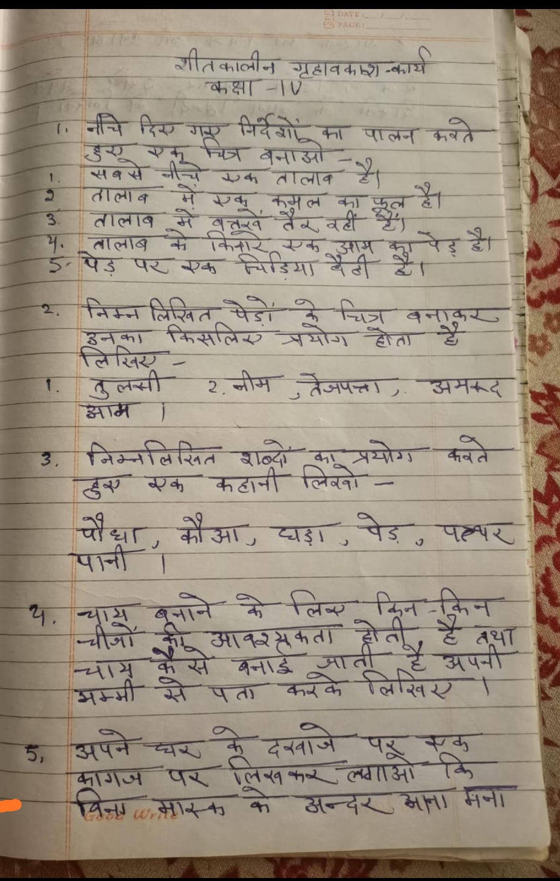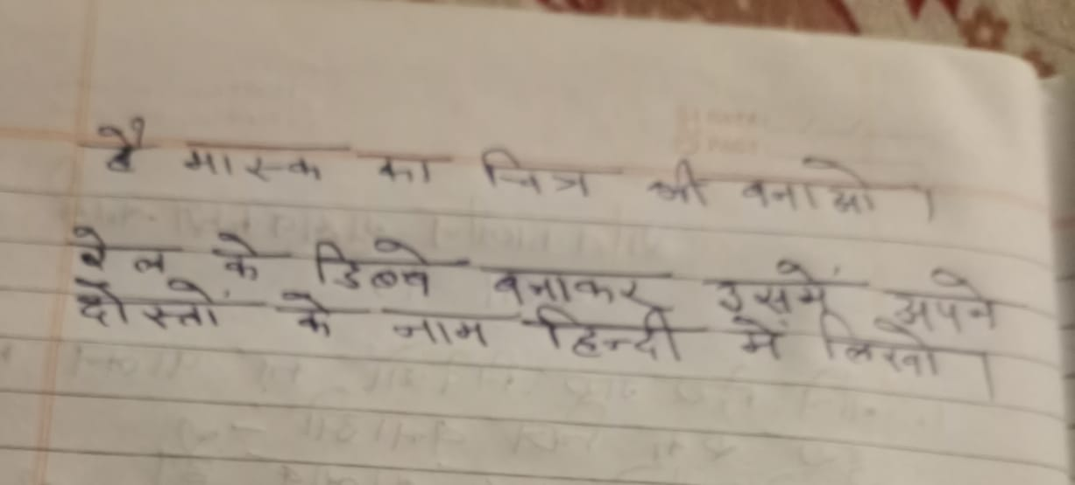

**Punjabi**

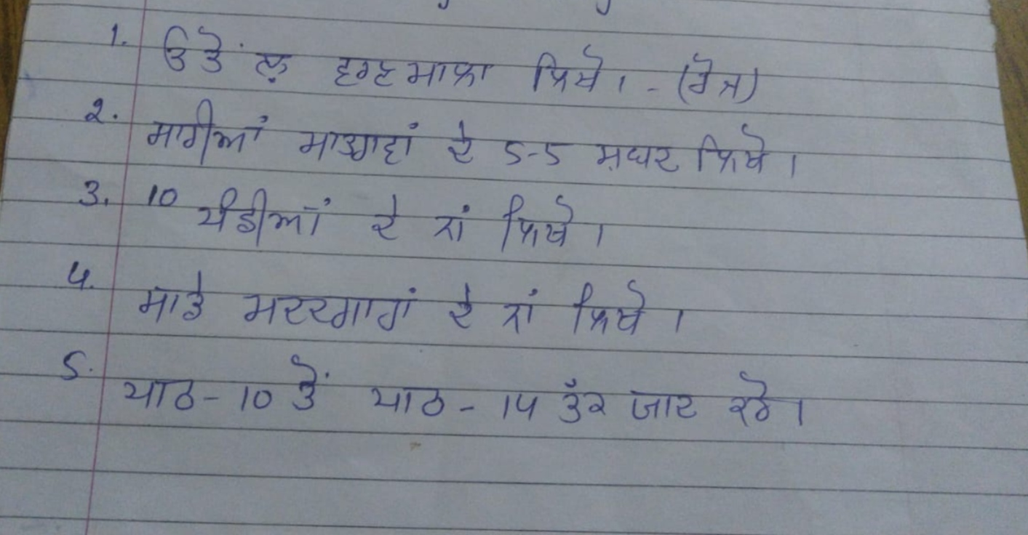

**Maths** – Do the given activity and worksheets in your Maths Notebook with complete calculations and sequence order.

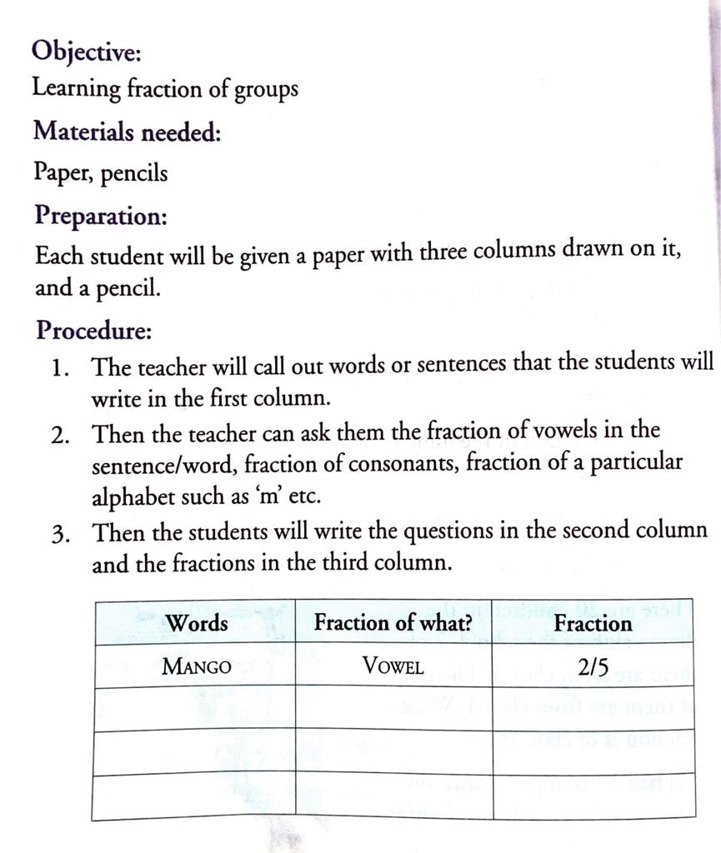

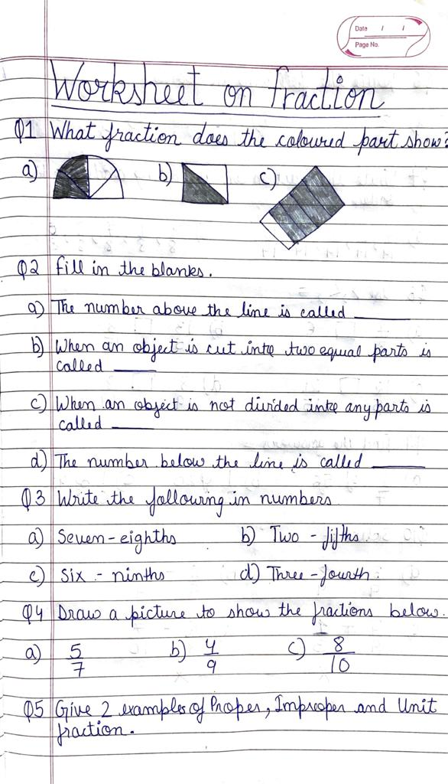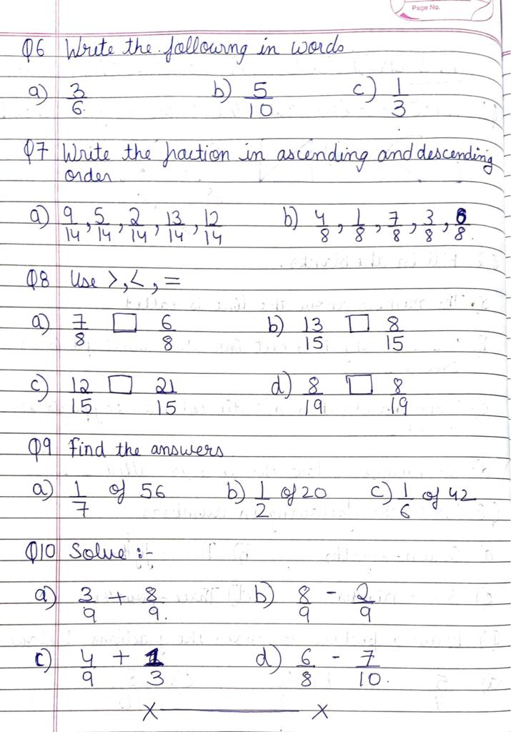

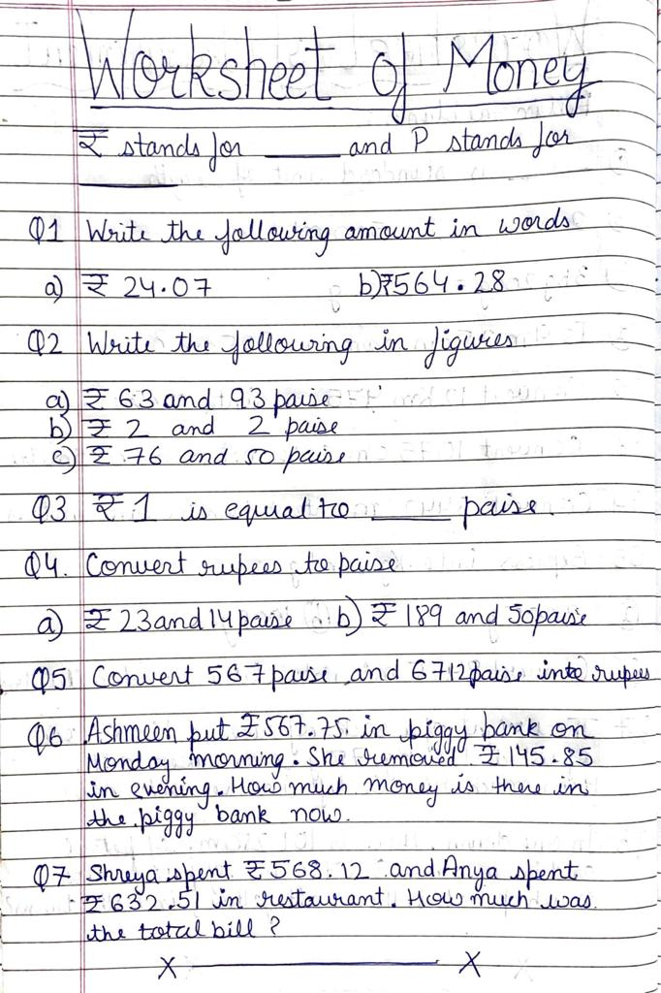

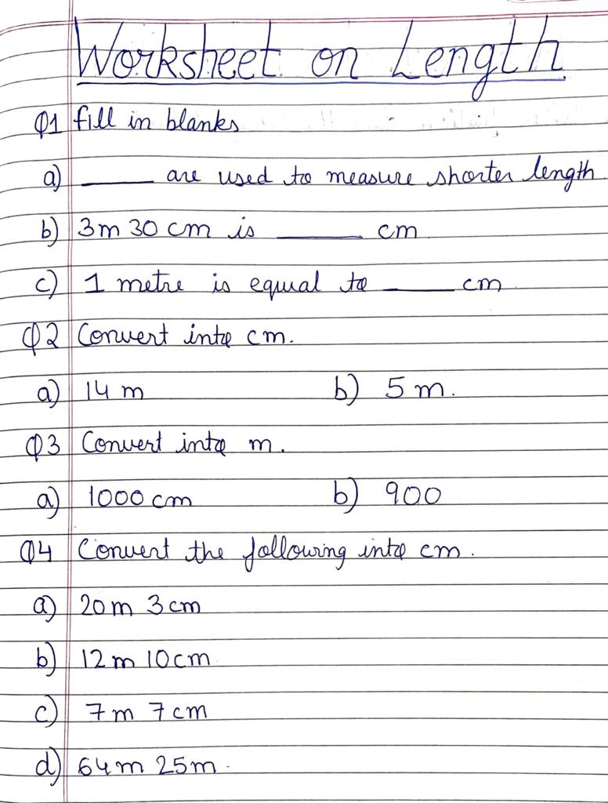

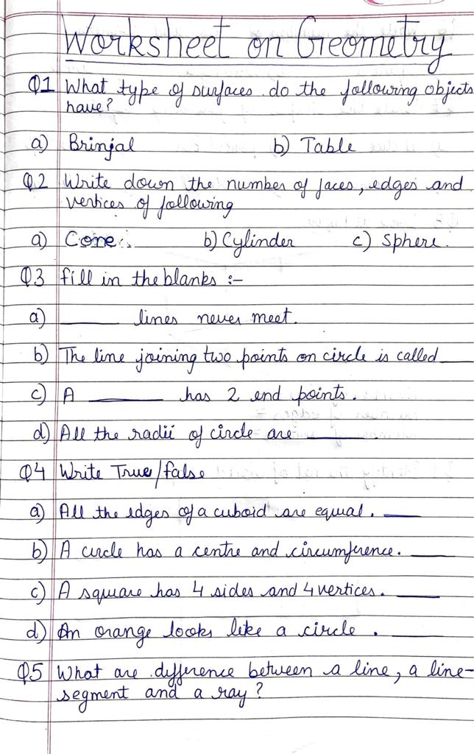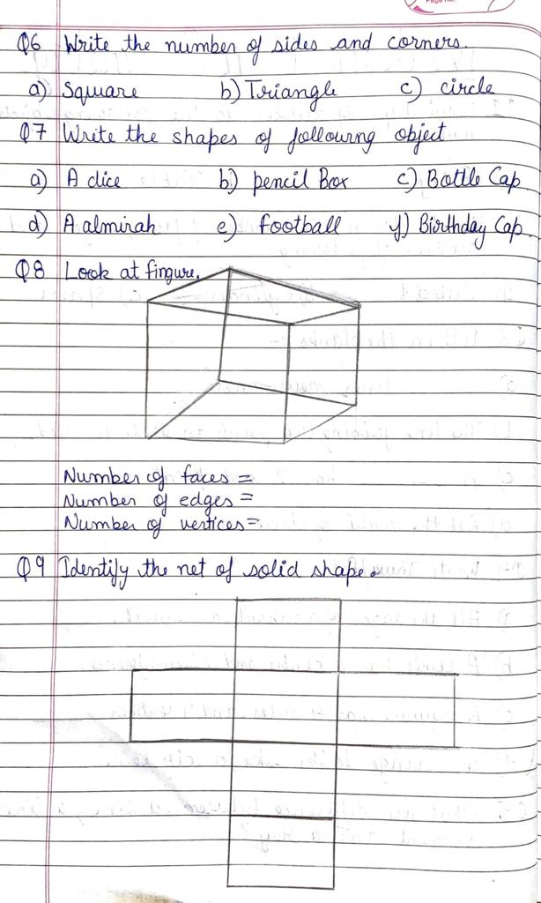 EVS

EVS

1)On an outline political map of India, mark the States of India along with the capital city. Paste the map in your EVS notebook and write the name of the States and their capital city.

2) On a chart paper paste the pictures of Living and Non- Living Things.

3) Make flash cards showing different types of houses.

**Art & Craft** –Do craft activity with dried pulses and grains as shown in given example.

