**BHAI JOGA SINGH PUBLIC SCHOOL**

**WINTER HOLIDAYS HOMEWORK**

**CLASS – II (2021-2022)**

English - Learn and write poem - The Swing in your notebook.

Evs- Write names and paste pictures of trees, herbs, shrubs and climbers on A- 4 size sheets

Mathematics-

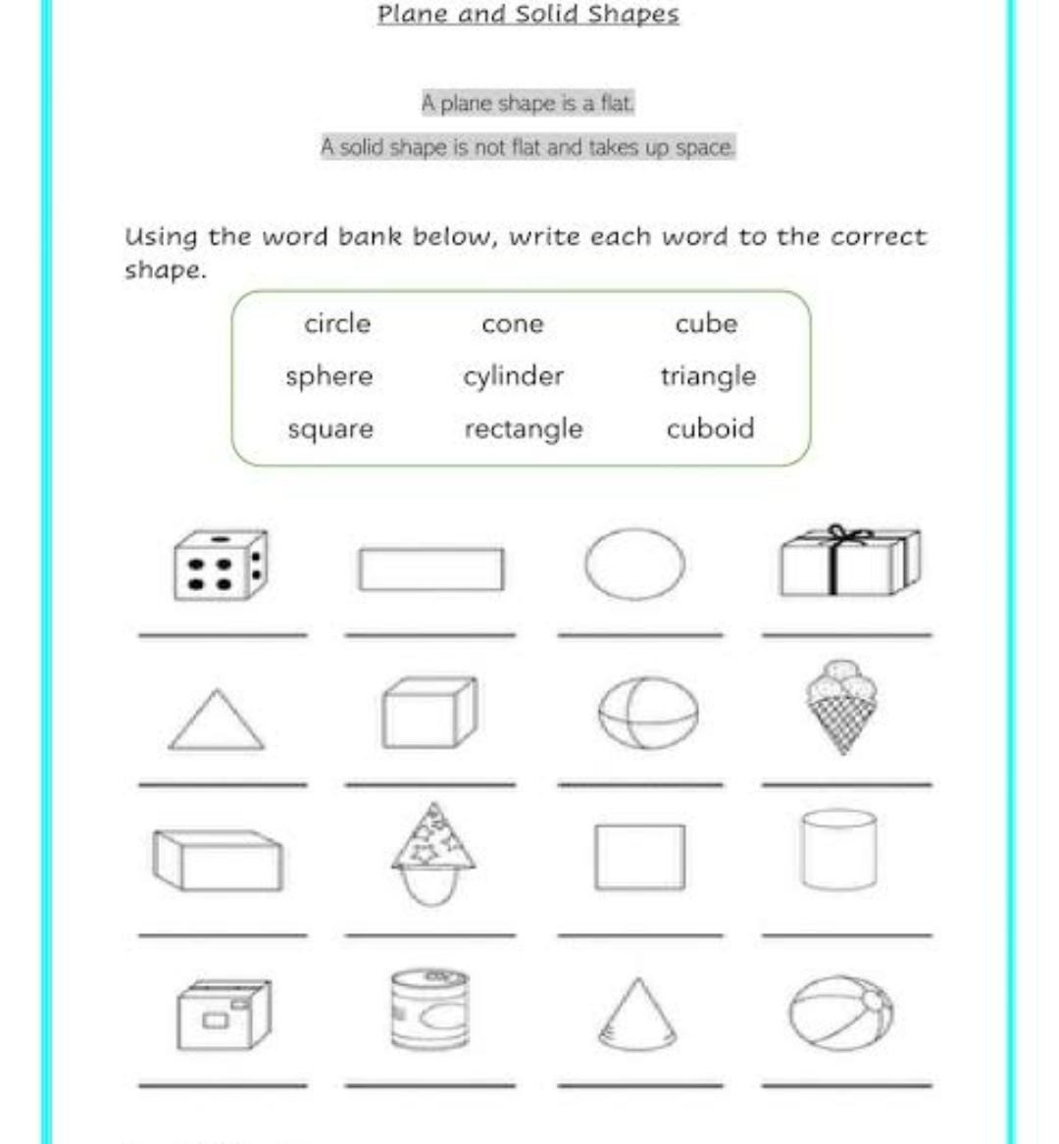

Do it in your notebook.

Hindi-

