**BHAI JOGA SINGH PUBLIC SCHOOL**

**WINTER HOLIDAYS HOMEWORK**

**CLASS – V (2021-2022)**

**English**

May this year bring new happiness, new goals, new achievements, and a lot of new inspirations on your life. Wishing you a year fully loaded with happiness. Wishing every day of the new year to be filled with success, happiness, and prosperity for you. Happy New Year.

I **ACTIVITY BASED TASK**- MAKE A THANK YOU CARD FOR THE PERSON YOU WANT TO THANK.AND PASTE THAT IN YOUR NOTEBOOK.

IIChoose the right adverb given in the brackets and fill in the blanks given.

1. I have been to the USA. (never/always )
2. They will go for dance practice .(yesterday/tomorrow) 3.We go to school on time.(today/always)
3. The child takes nutritious food .(never/ regularly)
4. I drink banana milkshake everyday. But my mother gives me mango milkshake.(rarely/always)

6.I looked for him .(somewhere/ everywhere)

7. My fathergoes for a morning walk .(sometimes/ regularly) 8.The test will be held . (tomorrow/yesterday)

1. IMAGINE AND WRITE A LETTER TO FRIEND DESCRIBING HOW TO CELEBRATED CHRISTMAS AND ABOUT YOURPLANS FOR NEW YEAR.
2. B. Fill in the blanks with suitable prepositions.
3. She ran the door.
4. They walked the city.
5. The boy fell the river.
6. I live 52 Palam Street.
7. The plane flew Jaipur.
8. The ground shook her.
9. My wallet is the briefcase.
10. The train went the tunnel.
11. I will meet you the airport.
12. Her bag was the chair.

11.I moved to Germany 1998.

1. The thief climbed the wall.
2. The trekkers walked --- the hill. 14.The satellite dish is the roof.

15.I have put the milk the fridge

1. COMPLETE THE SHEET

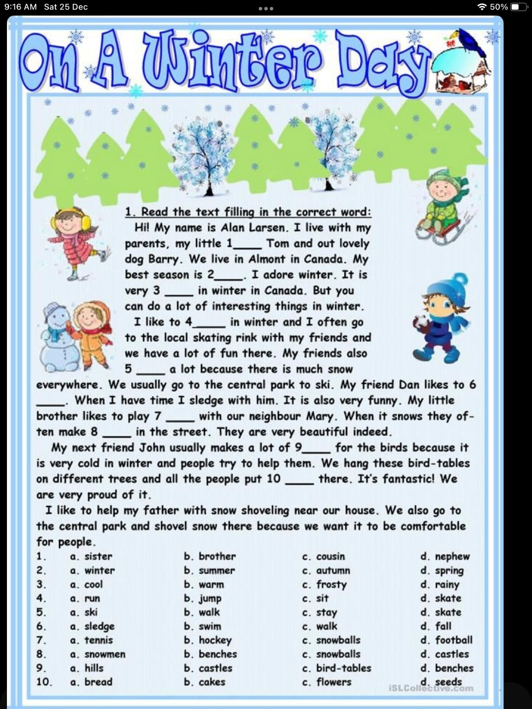

V I COMPLETE THIS SHEET

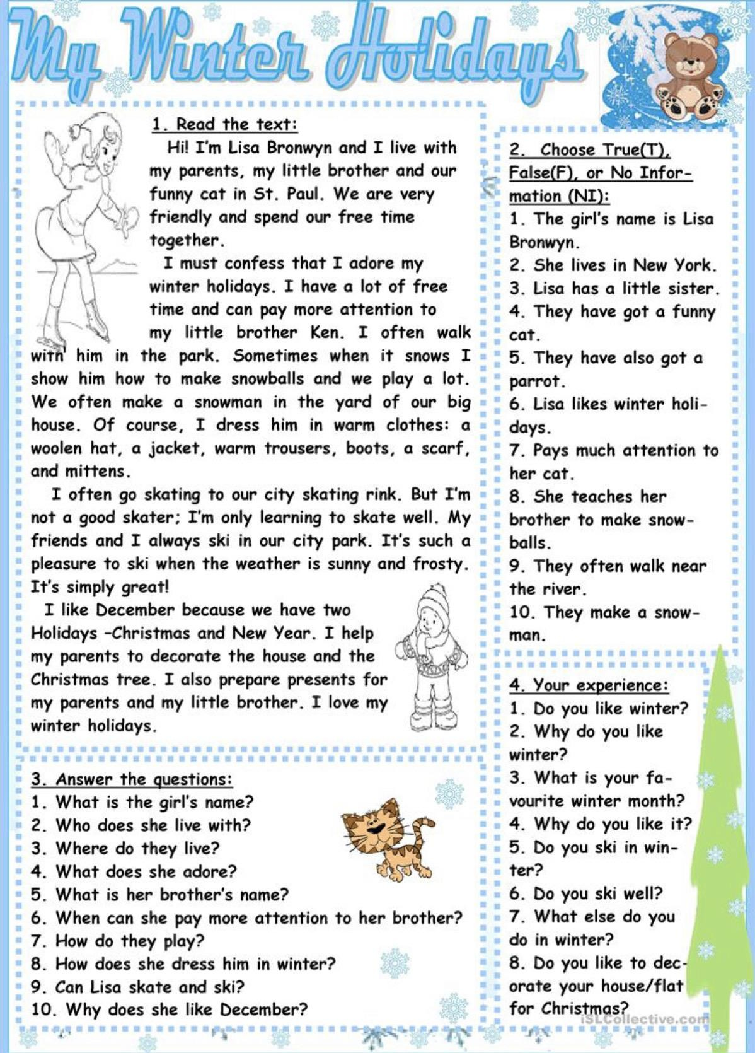

**Science**

1. Make a 3- D model on any one of the following
   1. The skull
   2. The ribcage
   3. The neuron
   4. The vertebral column
2. To prepare a project on any one natural calamity On A- 4 size sheets
3. Learn the chapters done. **Mathematics**
4. Make a poster on any one topic
   1. Types of triangles with the help of icecream sticks and name them
   2. Make a dice with the help of empty box
5. Do the given worksheets in your Maths notebook

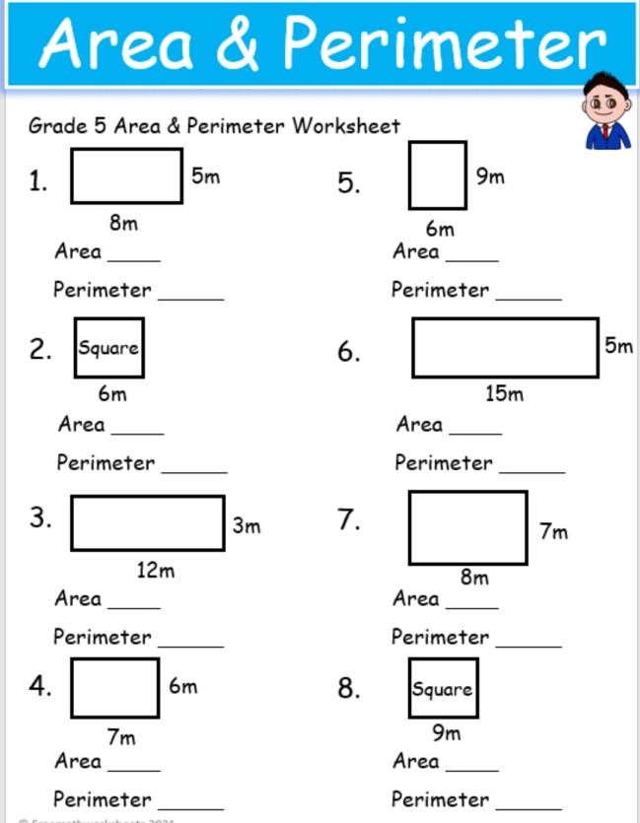

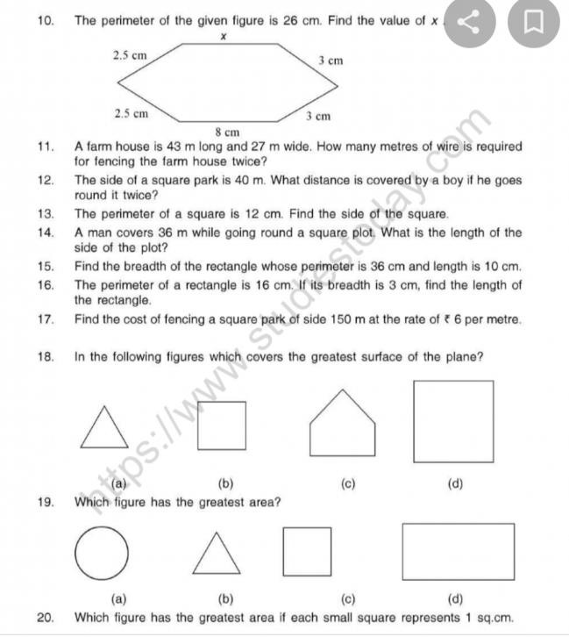Punjabi

j