**BHAI JOGA SINGH PUBLIC SCHOOL**

**WINTER HOLIDAYS HOMEWORK**

**CLASS – IX (2021-2022)**

**ENGLISH**

1. PROJECT Artificial Intelligence has made human life easy. Take one example of Al (Alexa, Siri, Drone delivery programs used by Amazon, Tesla making driver-less cars etc) and make a wall hanging (using cardboard and CDs) or a scrapbook depicting how Al impacts our lives.

2. STORY WRITING - What happens when a creative and enterprising school teacher stumbles upon Alexa? He could have used it like the rest of us do, but here is what he did instead. Rarely do we hear innovation story happening in places where you smell the heat and dust, walk through kachcha road dotted with sleepy village homes, sweat it out and get your feet dirty literally.

A thirty one year old school teacher is using Alexa to impart lesson to kids of farmers and laborers employed in the vicinity. Alexa naturally piques his interest and he believes that it could be a great teacher for his restless young students. Taking a cue from the above prompt, weave an interesting story around it in about 200 250 words. You may draw or use relevant picture cutouts to substantiate your story.

**HINDI**

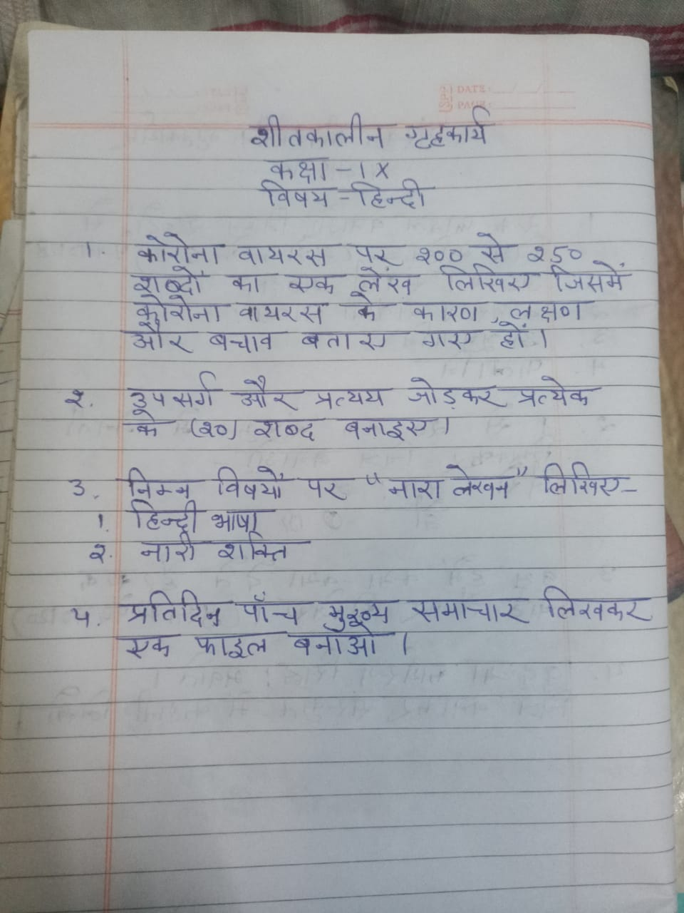

**PUNJABI**

ਖ਼ੁਸ਼ੀਆਂ ਆਪੇ ਨਹੀਂਆਉਂਦੀਆਂ

ਇਸ ਵਿਸ਼ੇ ਤੇ ਪਾਠ ਦੇ ਆਧਾਰ ਤੇ ਆਪਣੇ ਵਿਚਾਰ ਪ੍ਰਗਟ ਕਰੋ।

ਸਕੂਲ ਦੇ ਮੁੱਖਅਧਿਆਪਕ ਨੂੰ ਪੱਤਰ ਲਿਖ ਕੇ ਤੁਹਾਡੀ ਸਲਾਨਾ ਹਾਜ਼ਰੀ ਪੂਰੀ ਨਾ ਹੋਣ ਕਰਕੇ ਇਮਤਿਹਾਨਾਂ ਵਿੱਚ ਬੈਠਣਦੀ ਅਨੁਮਤੀ ਮੰਗਦੇ ਹੋਏ ਪੱਤਰ ਲਿਖੋ।

**SOCIAL SCIENCE**

Make a beautiful project file on Sikkim (art integrated) must be 10-15 sheets including culture, tradition,food, language,dressetc

Fill the following maps and paste in the portfolio of sst

**HISTORY**

Chapter-2: Socialism in Europe and the Russian Revolution

Outline Political Map of World (For locating and labeling / Identification)

* Major countries of First World War

(Central Powers and Allied Powers)

Central Powers – Germany, Austria-Hungary, Turkey (Ottoman Empire) Allied Powers – France, England, Russia, U.S.A.

**GEOGRAPHY (Outline Political Map of India)**

Chapter -3: Drainage

* Rivers: (Identification only) o The Himalayan River Systems-The Indus, The Ganges, and The Satluj o The Peninsular rivers-The Narmada, The Tapi, The Kaveri, The Krishna, The Godavari, The Mahanadi
* Lakes: Wular, Pulicat, Sambhar, Chilika

Chapter – 4: Climate

* Areas receiving rainfall less than 20 cm and over 400 cm (Identification only)

**MATHS**

Models (prepare any one)

1. Design a crossword puzzle related to mathematical concepts.

2. Prepare windchime using mathematical shapes .

3. Relate polynomial to daily life.

Projects( prepare any one)

1. Historical details of zero.

2. Mathematics behind metro routes.

3. Mathematics through newspapers.

Charts ( prepare any one)

1. Algebric identities

2 . Area of parallelogram using graph paper

3. Euclid's axioms and postulates

**SCIENCE**

**CHEMISTRY**

1. Read about at least five scientists and their contribution in Chemistry and write at least 50 words on each scientist on A4 size sheets.
2. Draw neat and well labelled diagrams of Atom Models on A4 sheets.
3. **ACTIVITY**

As we know that the petrol and diesel prices are shooting up each month, apart from this, these fuels are polluting the environment by emitting harmful gases.

Thus it becomes necessary to look for a better alternative like CNG, which serves in terms of

economy and health

**Objectives:**

• To know the origin, mechanism of production, composition of CNG .

• To enlist the CNG plant locations in India.

• To understand the advantages of CNG.

**Methodology:**

1. Students are going to prepare a brief research report on CNG. They may include the following points:

• Origin

• CNG plant locations In India (preferably on a map).

• Mechanism of production.

• Capacity.

• Cost.

• Precautions while transportation .

• It’s advantages.

2. They will record everything in a file / PPT /scrapbook. If possible, they will justify their research report with pictures/diagrams to make it more presentable and creative.

**Evaluation**:

➢Each student will be evaluated on the basis of:

▪ Active participation.

▪ Honesty and Dedication.

▪ Presentation.

▪ Innovation.

**PHYSICS**

1. Read about at least five scientists and their contribution in Physics and write at least 50 words on each scientist on A4 size.
2. Search and read about new theories and inventions in Physics.

**BIOLOGY**

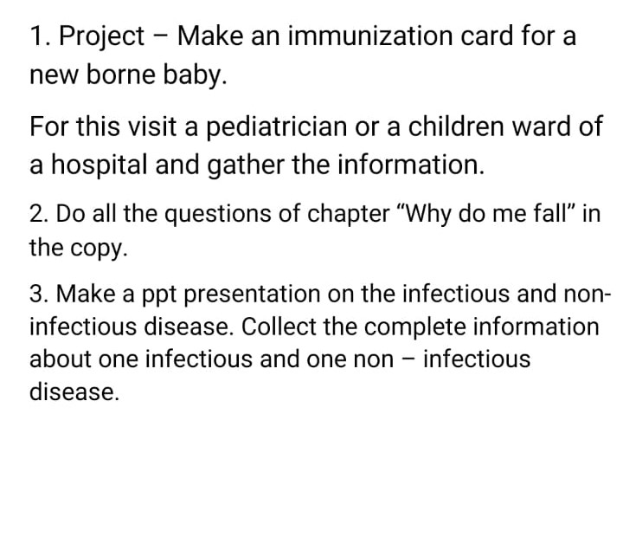

**IT**

Create a table ‘Reservations’ by using the Table Design View in Railway database and define the following fields :-

[Customer ID , Amount Paid , Deposit Due , Reservation ID , Reservation Date , Reservation Time , Total Due]

*Set the Customer ID field as the primary key with auto-generation number.