**BHAI JOGA SINGH PUBLIC SCHOOL**

**WINTER HOLIDAYS HOMEWORK**

**CLASS – KG (2021-2022)**

ENGLISH-

Paste pictures of three letter words of vowel (a, e and i) in your school notebook.

HINDI-

Write Vyanjan in your note book (5 times).

MATHS-

Write number names 1 to 10 and paste the picture according to the number

s**Art & Craft** – Create a painting with help of Fingers and Hands.

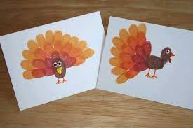`

* Do the Page No.10 (Butterfly Activity) from Art and Craft Book.