**BHAI JOGA SINGH PUBLIC SCHOOL**

**WINTER HOLIDAYS HOMEWORK**

**CLASS – NURSERY (2021-2022)**

**ENGLISH**-

Paste the pictures of alphabets A to Z in your notebook.

**MATHS-**

Make a figure and number it 1 to 17 and tell your child to draw the figure and colour the same.

You can google it for ore ideas.

MAKE A DIFFERENT FIGURE

**Art & Craft** – Create a Craft with “Tissue Paper”.

`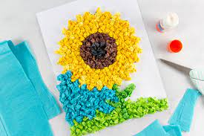

* Do the Page No.16 and 17 in Art and Craft Book.
* **HAPPY HOLIDAYS!!!**